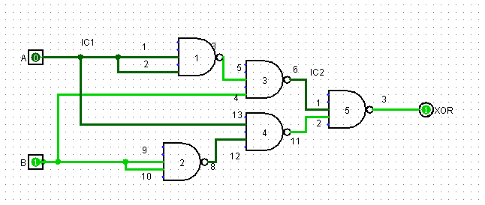
Implementation of XOR using NAND gates

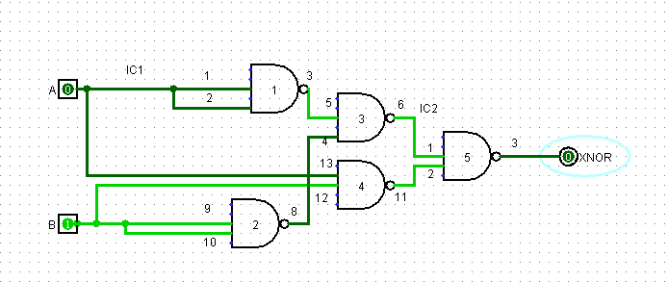
Implementation of XNOR using NAND gates

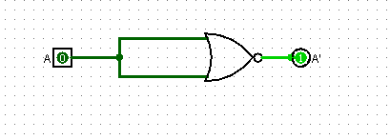
Implementation of NOT using NOR gates
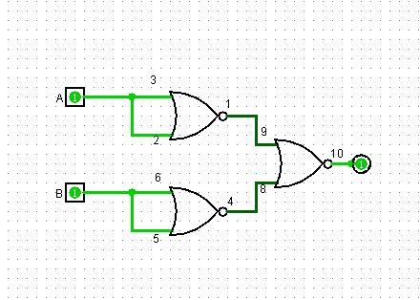
Implementation of AND using NOR gates

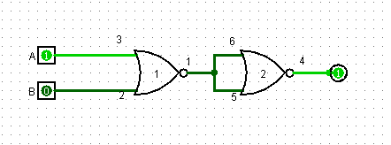
Implementation of OR using NOR gates
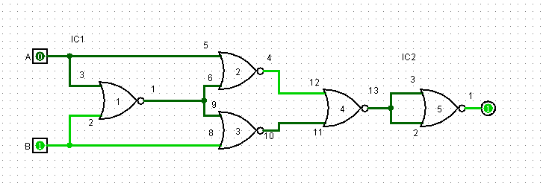
Implementation of XOR using NOR gates
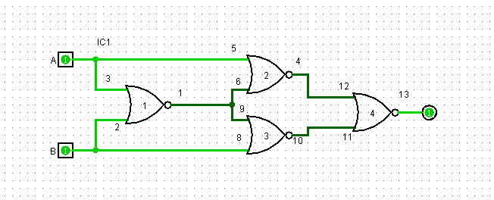
Implementation of XNOR using NOR gates
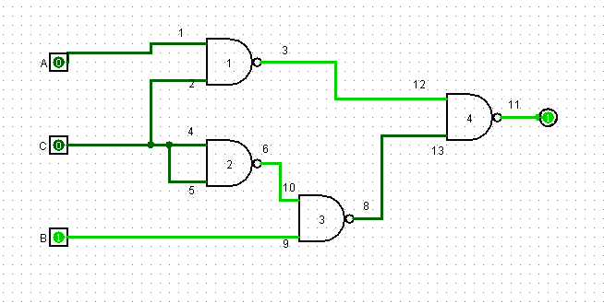
Figure F3: Universal (NAND) gate implementation of the circuit of Figure D2

